An introduction to macroeconomics

# LO6.1 Explain why economists use GDP, inflation and unemployment to assess the economy’s health

* Macroeconomics is primarily concerned with long-run economic growth and the short-run fluctuations in output and employment that comprise the business cycle.

## Objectives of the government

* Sustainable economic growth 🡪 long run objective
* Low unemployment
  + Below 2% is ideal
  + 4% is okay but not good
  + Above 6% is bad
* Low inflation 🡪 price levels must be stable
  + Purchasing power
  + Firms need this to make good decisions
* Balance of payment equilibrium

## Real GDP

* Real GDP measures the value of the final goods and services produced within a country’s borders during a specific period of time, typically a year.
  + Very useful as it tells us whether an economy’s output is growing
* To calculate the value of real GDP 🡪
  + First calculate nominal GDP, which is the dollar value of all goods and services produced within a country’s borders using their prices during the year they were produced
  + Then adjust to price changes
* Real GDP accounts for price changes
  + Compare real GDP numbers from one year to the next and really know if there is a change in output

## Unemployment

* Unemployment occurs when a person cannot get a job despite being willing to work and actively seeking work.
* High unemployment rates are undesirable because they indicate that a nation is not using a large portion of its most important resource – the talents and skills of its people
* There are links between higher unemployment rates and major social problems such as higher crime rates, greater political unrest, and higher rates of depression and heart disease among unemployed people

## Inflation

* Increase in the overall level of prices

## Preview

* Real GDP, unemployment and inflation are standards by which economists keep track of long-run growth and short-run fluctuations

# LO6.2 Discuss why sustained increases in living standards are historically recent

* Before the industrial revolution, the economies did increase. However, as their output increased, their populations increased by similar proportions so that the amount of output per person remained virtually unchanged.
* Industrial revolution
  + Ushered in not only factory production and automation but also constantly improving production technologies thanks to an emphasis on research and development
  + Output began to grow faster than the population, and living standard began to rise as the amount of output per person increased.
* In countries experiencing modern economics growth, output per person rises
* Today, the citizens of the world’s richest nations enjoy material standards of living that are on average more than 50 times higher than those experienced by citizens of the world’s poorest nations

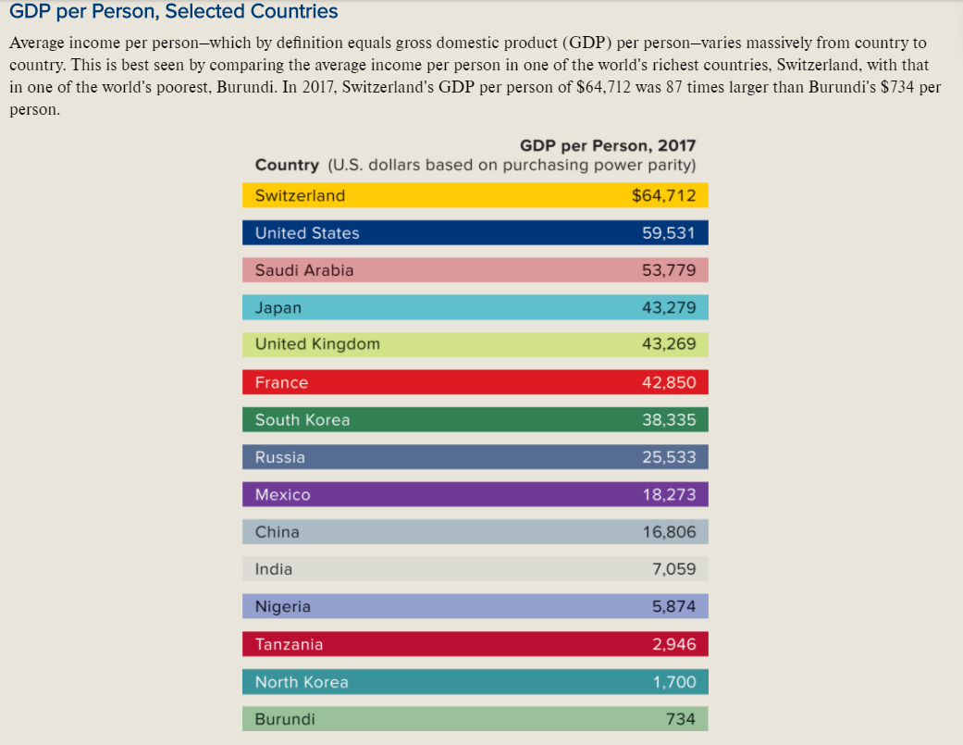

# LO6.3 Identify why saving and investment promote higher living standards

* To raise living standard over time, an economy must devote at least some part of its current output to increasing future output
  + Saving occurs when current consumption is less than current income; the difference between them is savings
  + Investment happens when resources are directed toward increasing future output – either by paying for research to develop more efficient production technologies or by paying for the production of newly created capital goods (such as machinery, tools, and infrastructure) that will increase future output
* The amount of investment is ultimately limited by amount of saving
* Individuals and society as a whole must make trade-offs between current and future consumption

|  |
| --- |
| **Financial investment** refers to the purchase of assets like stocks, bonds and real estate in the hope of reaping financial gain. **Economic Investment** relates to the expansion of the economy’s productive capacity. It includes spending that pays for the production of newly created capital goods like factories and wireless networks as well as the costs of developing new technologies like solar powered helicopters or a cure for cancer. |

## Banks and Other Financial Institutions

* Banks and other financial institutions (such as mutual funds, pension plans, and insurance companies) act as intermediaries between households and businesses
* These institutions collect households’ savings, rewarding savers with interest, dividends or capital gains (increases in asset values)
* They then lend the funds to businesses, which invest in equipment, factories, and other capital goods as well as research and development.
* Macroeconomics devotes considerable attention to money, banking, and financial institutions because a well-functioning financial system promotes economic growth and stability by encouraging saving and by directing that saving into the most productive possible investments
* In contrast, a poorly functioning financial system can create serious problems for an economy

# LO6.4 Explain why shocks and sticky prices are responsible for short-run fluctuations in output and employment

* The future is uncertain
* Firms spend considerable time trying to predict future trends so that they invest only in projects that are likely to succeed.
* Macroeconomics must take into account expectations about the future

## The Importance of Expectations and Shocks

* Effects of changing expectations on current behaviour
* If firms grow more pessimistic about the future returns that they expect from current investment, they will invest less today than they would if they were more optimistic
  + Increased pessimism leads to less current investment and subsequently less future consumption
* What happens when expectations are unmet
  + Firms are often forced to cope with shocks – situations in which they were expecting one thing to happen but something else happened instead
* Economies experience both demand shocks and supply shocks
  + Demand shocks are unexpected changed in the demand for goods and services
  + Supply shocks are unexpected changes in the supply of goods and services
  + Shocks are not good or bad
  + Hence the word positive and negative must be used to make it more specific

## Demand Shocks and Sticky Prices

* Economists believe that most short-run fluctuations in GDP and the business cycle are the result of demand shocks
* Supply shocks do happen and are very important when they do
* Prices are inflexible / sticky in the short run
* Since prices are inflexible, the economy is forced to respond in the short run to demand shocks primarily through changes in output and employment rather than through changes in prices

## Example: A Single Firm Dealing with Demand Shocks and Sticky Prices

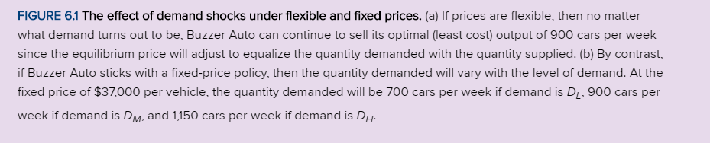

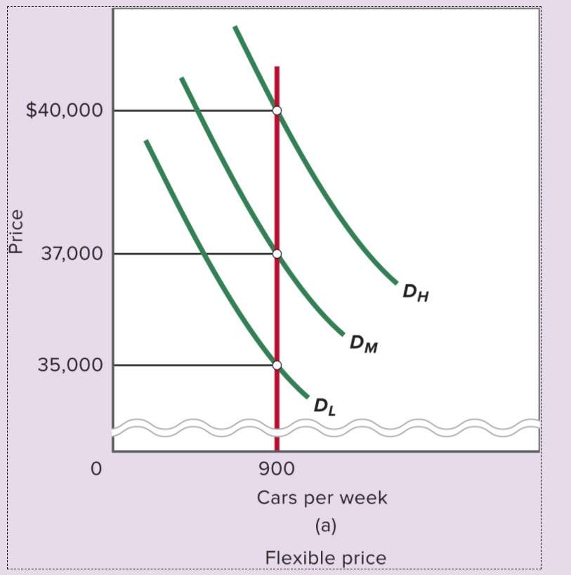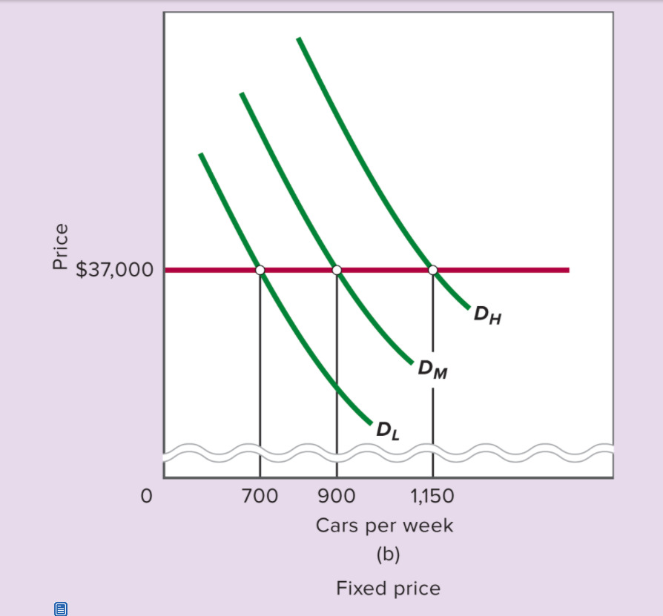

* If the prices can easily adjust to the demand, the company would always sell at 900.
  + No change in output and no change in employment
* But the prices are usually sticky, and the company does not change prices
  + Cars sold would change
  + Inventory (stock of output that has been produced but not yet sold) changes
  + But when inventory keeps increasing over time, due to low demand, the company is forced to cut production and retrench workers.
  + But when inventory keeps decreasing over time, due to high demand, the company has to hire more workers

# LO6.5 Characterize the degree to which various prices are sticky

* Not all prices are sticky
* Markets for many commodities and raw materials such as corn, oil, and natural gas feature extremely flexible prices that react within seconds to change in supply and demand
* Companies selling final goods and services know that consumers prefer stable, predictable prices that do not fluctuate rapidly with changes in demand
* Volatile prices make planning more difficult
* A firm may fear cutting its prices as it be counterproductive due to price war

# LO6.6 Explain why economists use different macroeconomic models for different time horizons

* Different models are needed because the economy behaves so differently depending on how much time has passed after a demand shock
* Employee psychology appears to play a key role in price stickiness
  + Major cause of sticky output prices is the stickiness of particular input price – the price of labour, that is wages
  + Wages and salaries make about 70 percent of the average firm’s costs
  + Workers retaliate when their wages or salaries are reduced
  + Hence firms to prevent counterproductivity will retrench the workers
  + Morale and productivity may even rise because the workers who remain employed may be grateful to still have paying jobs while many millions of workers across the economy are plunged into unemployment as a result of recession